**CIND 119: Introduction to Big Data Analytics**

**Assignment 3**

**Submitted by:**

**Marco Muto**

1. 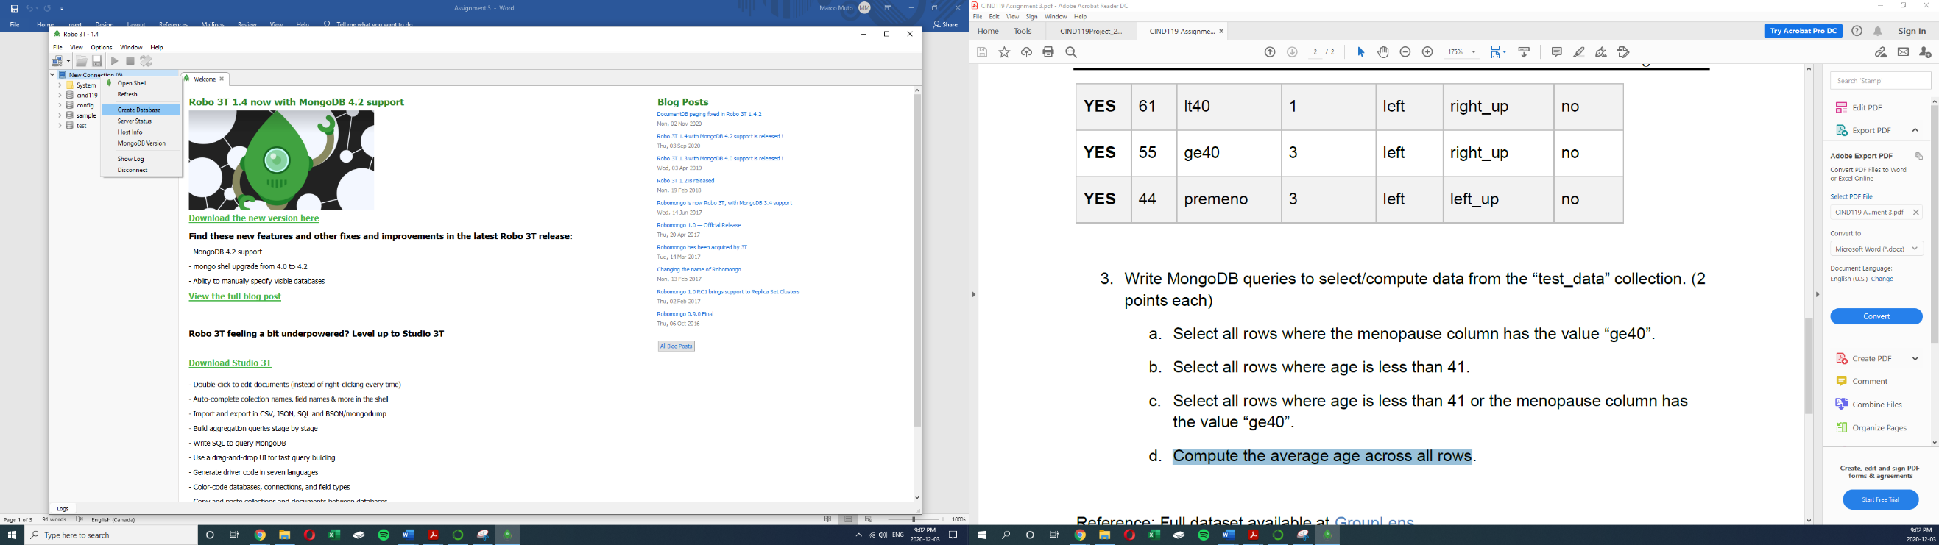Create database called “sample”

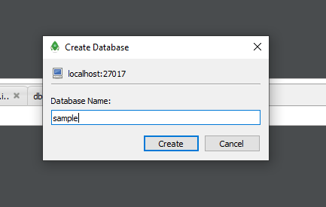

1. Create a collection called “test_data” and load the following data into the collection.

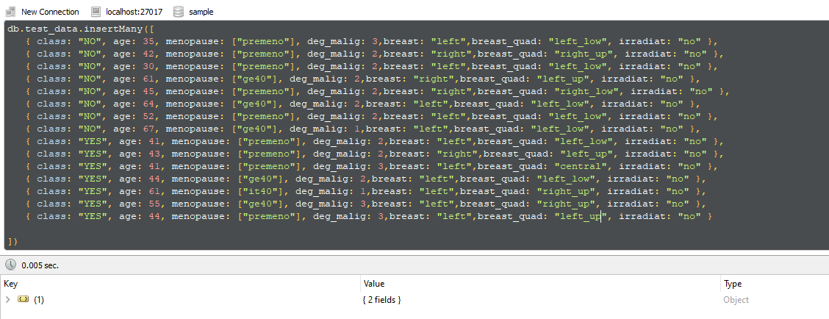

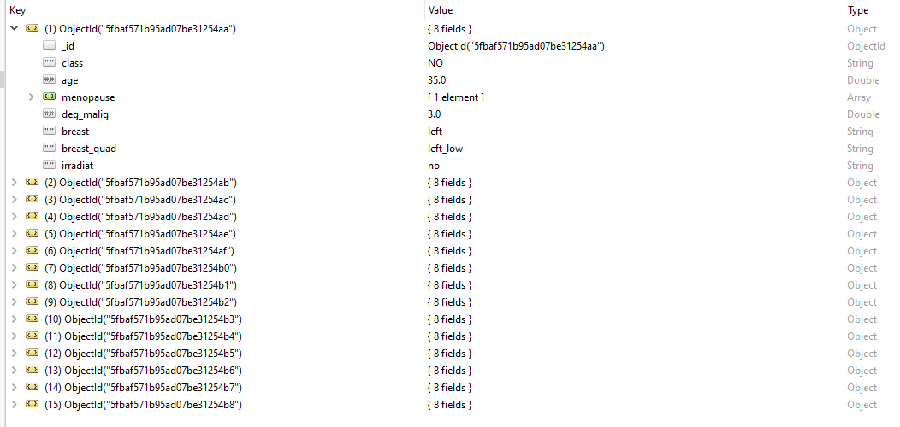

1. Write MongoDB queries to select/compute data from the “test_data” collection.

3a. Select all rows where the menopause column has the value “ge40”.

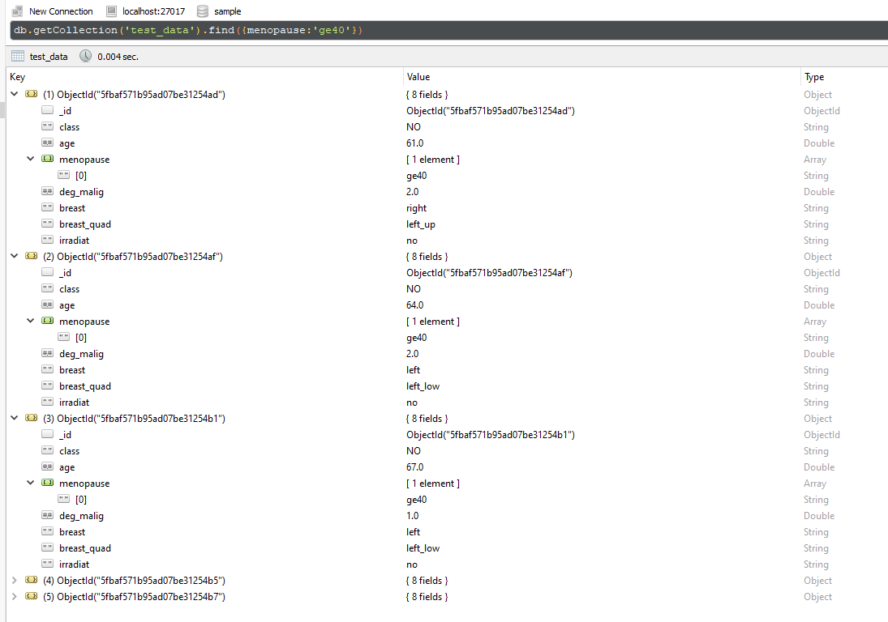

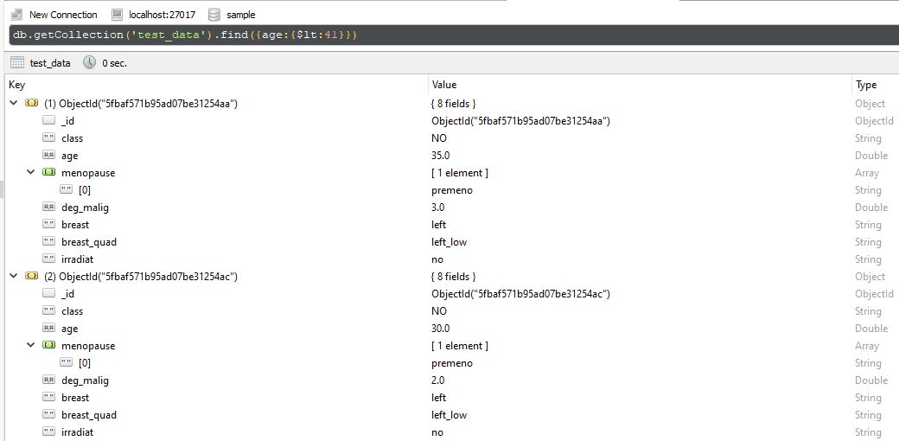3b. Select all rows where age is less than 41.

3c. Select all rows where age is less than 41 or the menopause column has the value “ge40”.

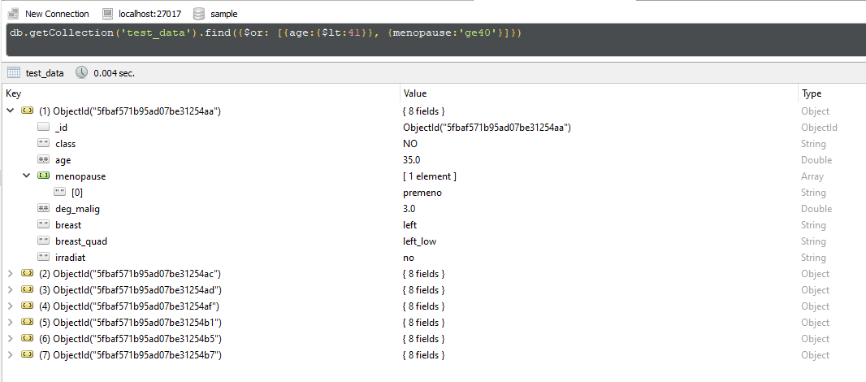

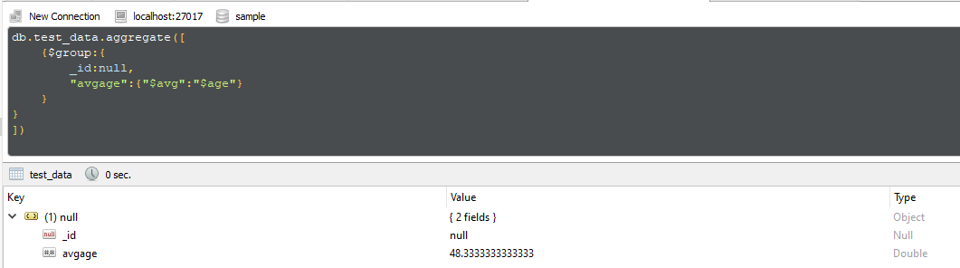3d. Compute the average age across all rows